
UPS with automatic
output voltage regulation

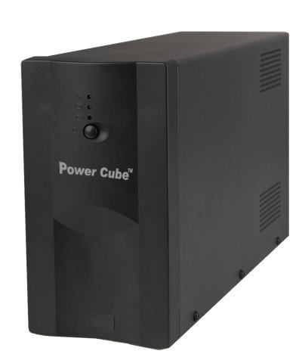
Disclaimer
- We spared no efforts to make sure that the information in this manual is correct and complete. However no liability is accepted for any errors or omissions. Gembird Electronics reserves the right to change the specifications of the hardware and software described in this manual without prior notice.
- No part of this manual may be reproduced, transmitted or translated in any language in any form, by any means, without the prior written permission of Gembird Electronics Ltd.
- Gembird Electronics makes no warranties for damages resulting from corrupted or lost data due to a mistaken operation or malfunction of the product, the software, personal computers or peripheral devices.

Gembird® is a registered trademark of GMB Tech (Holland) bv.
Other names or products not mentioned above may be registered trademarks or trademarks of their respective owners.

Copyright © 2008 Gembird Electronics Ltd. All rights reserved.

UPS User manual

Introduction

Thank you for buying the Gembird® UPS with automatic output voltage regulation! This manual will help you install and use it properly.

Features

- Automatic output voltage regulation (AVR)
- USB controlling interface (for advanced models)
- LED status indication
- Short circuit protection
- Surge, spike and lightning protection
- Audible and visual alarms
- Overcharge and over discharge protection
- Fax/Modem/Telephone or other protection socket (for advanced models)

Package contents

- UPS
- Power cord
- Spare fuse
- USB cable and software CD (for advanced models)
Specifications
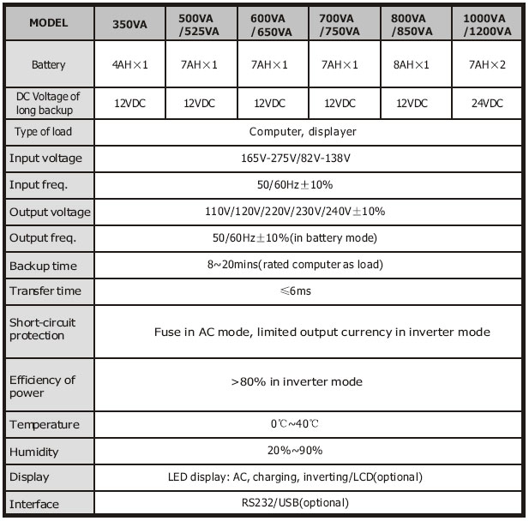
Remarks about Safety

In order to keep safe in using the UPS, please comply with the following:
- Please charge the battery at least 12 hours before the UPS is in operation.
- After the battery is discharged or over three months without operation, the battery should be charged immediately for at least 12 hours, ensuring the battery is full and avoiding any unnecessary damage of the battery.
- The UPS is specially designed for computer only and it should not be connected with any inductive or capacitive load, or the pure resistance full load, like electromotor, daylight lamp, laser printer, etc.
- It is normal that the temperature of the UPS surface reaches up to 50 when it is in operation.
- When AC fails and the ON button on the front panel is pressed, the UPS will output voltage; if the OFF button on the front panel is pressed, the UPS will not output voltage.
- It is forbidden to open the case, because there is danger with electricity. If there is problem, please handle with the instruction of experts.
- It is forbidden to put container containing liquid inside on the UPS, because it will cause danger of electric shock or fire when the UPS short-circuits.
- When the UPS work looks abnormal, please cut off power immediately and turn to experts or the dealer for help.
- Do not overload the UPS. Otherwise, it would cause danger.
- It is strictly forbidden to place and operate the UPS in the following environment:
  - Place with inflammable gas or corrosive gas or much dust
  - Place with very high temperature or very low temperature (above 42C or below 0C) or high humidity(above 90C )
  - Place with direct sunlight or near heater
  - Place with strenuous vibration
  - Outside
- Please use dry powder fire extinguisher in case of fire; it is forbidden t o use fluid fire extinguisher because it will cause electric shock.
- Please put the socket near the UPS, in this way, it is convenient to disconnect the socket and cut off power in case of emergency.
- The UPS is not suitable for being used in life support systems, because it may have some problems and bring trouble to the life support systems. The responsibility will lay on the end-users, if they insist on using the UPS in life support systems.
ALARM: The UPS must be connected to the grounded AC mains!

Working Principle
In AC mode
When UPS is in normal working mode, AC goes through the filter and the harmful waves are filtered. After that, AC charges the battery and meanwhile, passes UPS AVR and the filter and provide power for the equipment.
AC Failure
When AC fails, the battery will supply power to the inverter and then passes filter and provide power for the equipment, ensuring the continuous power supply.

Battery and Charging
- When the UPS is connected to AC, the charger will charge the battery fully in about 10 hours.
- When the battery is used up, please charge the battery immediately so that to prolong the life of the battery.

Main Features

Unattended Operation
- Please connect the UPS to AC and press the ON button on the front panel, the UPS is turned on and the AC outputs stabilized voltage.
- When AC fails, UPS will supply power to the equipment immediately. And when the battery is used up, UPS will turn off automatically.
- When AC comes back, UPS will turn on automatically.

Protection
- Battery over discharge protection when the battery discharges and the UPS is in inverter mode, the battery will check and monitor the working status of the battery; when the battery voltage drops to the limited lowest voltage, the inverter will turn off automatically and protect the battery; When AC comes back, UPS will turn on automatically.
- Short-circuit Protection when UPS is in inverter mode and there is shock or short-circuit, UPS will output limited currency, protecting the UPS (When in AC mode, the UPS will be protected first by input fuse and then transfers to the inverter working mode).

Interface Port (with function of intelligent monitoring of computer):
- This series UPS can have DB9 or USB interface port, which can service for such systems as MS-DOS, WINDOWS, NOVELL, UNIX, LAN, etc and keep files and monitor UPS to turn off automatically.
- Automatically check AC normal or bad and the battery voltage and send the alarm massage to all the working systems.
- When AC fails, the UPS will turn off the systems and the UPS automatically.
- The interface provides the function of predicting and setting the time of uninterruptible power supply and record the UPS and AC status.
- Display the count-down time of turnoff of the UPS.
- Monitoring UPS remotely by TCP/IP.
- The interface can set the time of self-testing of the UPS and time delay of turnoff

Three Kinds of Alarm Function (new model)
- When AC fails, and the UPS supplies power, UPS will alarm once every 6 seconds and the beep stops about 40 seconds later.
- When the battery is nearly used up, the UPS will alarm automatically and the beep frequency is once every 2 seconds.
- When the battery is really used up, the UPS will alarm for a very long time and after 20 seconds, it will turn off automatically.

Lock Phase Function (new model)
In AC mode, the UPS system automatically tracks AC phase and ensures that the output wave form of the inverter is the same with AC voltage wave form, in this way, it reduces the peak pulse and surge voltage and minimizes the interference and damage to the equipment.

The Function of the Self-set Frequency
When the UPS is turned on for the first time, the acquiescence frequency is 50/60Hz; when it is connected to AC, the frequency is automatically set to 50Hz or 60Hz in accordance with AC.

Overview
The advanced models of UPS have USB or RS-232 interface port to be controlled by the computer, extra surge protected sockets (telephone/fax).
Installation and Operation

- Shut down the load (for example PC), pull out power gird
- Put UPS on the proper position(following the manual)
- Connect load (for example PC) to the UPS
- Put the plug to the AC power socket
Suggestion: OFFLINE UPS is the power supply for the computer monitor and hard disk (CD) etc. It has the limited back time for the load, so you should better not connect the printer or other equipments to it.

- Connect to AC: press the panel switch turning on the UPS, the green LED and yellow LED light, then you can turn on your computer etc.
- Battery mode press the panel switch turning on the UPS, the red LED lights then you can turn on your computer etc.
- Normally turning UPS press the panel switch turning on the UPS.
- Normally turning off UPS press the panel switch turning off the UPS.

Remark
  - Generally speaking, do not turn off the UPS and keep battery charging.
  - Once AC fails, UPS will turn to battery mode, please save important documents in time.
Maintenance

Preventative Maintenance
Preventive Maintenance ensures the longer Service life of UPS. Please check the following steps every month:
- Turn off the UPS;
- Make sure the airway not blocked;
- Make sure that the UPS surface is not covered by dust;
- Check whether the input, output and battery connecting lines are firm or not and the insulation is effective or not;
- Make sure that the UPS is not affected with damp;
- Turn on the UPS;
- Let the UPS work in battery mode for about 5 minutes and in this period, if there is no other alarm from the UPS, then the UPS is normal; if there is other alarm message, please, contact the local dealer for help.

Battery Maintenance
The UPS contains sealed lead-acid maintenance-free battery. The bad environment, the high discharge frequency, the high temperature, etc will dramatically reduce the use life of battery. The use life of battery will also reduce even it is not used. It is suggested to discharge the battery once every 3 months when AC is normal.
The following is the steps of how to check the battery: when the battery is near the end of its life, the battery will end in bad performance. So, please remember the following steps of checking and maintenance:
- Connect the UPS to AC and turn on the UPS, charge the battery for at least 10 hours , noting the load status.
- Keep the load at that status and record the total power capacity of the load and then remove the input plug of the UPS( simulate AC failure), and the battery of the UPS will discharge until turn off automatically and record the discharge time. Please keep the record of the discharge time for later check.
- The battery service life is about 2 to 3 years in normal conditions. But in such condition as: high temperature or high discharge frequency, the battery service life will reduce to about 0.5 to 1 year.
- With the operating time passed, the capability of battery will be weakened (the discharge time will decrease). When the discharge time is 80% of the initial discharge time, the performance of the battery will be weakened faster and accordingly, the checking frequency of the battery should change from once every half year to once every month.

Handling of abnormity
The UPS can serve and provide protection to users' equipment, but if there is something abnormal, please turn to local UPS dealer for help, avoiding unnecessary damage to the UPS.
When the UPS has the following problems, please follow the Steps below and if the problem still can not be solved, please contact the local dealer.

Phenomenon | Trouble Shooting
Battery fails to supply power. | Check whether the battery isn't charged charge enough Check whether the UPS is not turned on correctly?
UPS doesn't turn to AC (the input plug of the UPS has been plugged into the AC socket and AC is normal, and the on button has been pressed, but the AC indicating light is not bright and the alarm beeps. | Check whether the fuse is broken? The fuse is placed on the UPS back panel. After disconnecting the AC plug, put out the fuse and check whether the fuse is broken, if so, please replace it with a new fuse.
When AC fails, the computer doesn't work. | Please turn on the UPS and charge the battery for at least 10 hours, when AC is normal and then turn on the UPS.
AC output is normal, but the alarm beeps. | AC is over voltage or low voltage.

